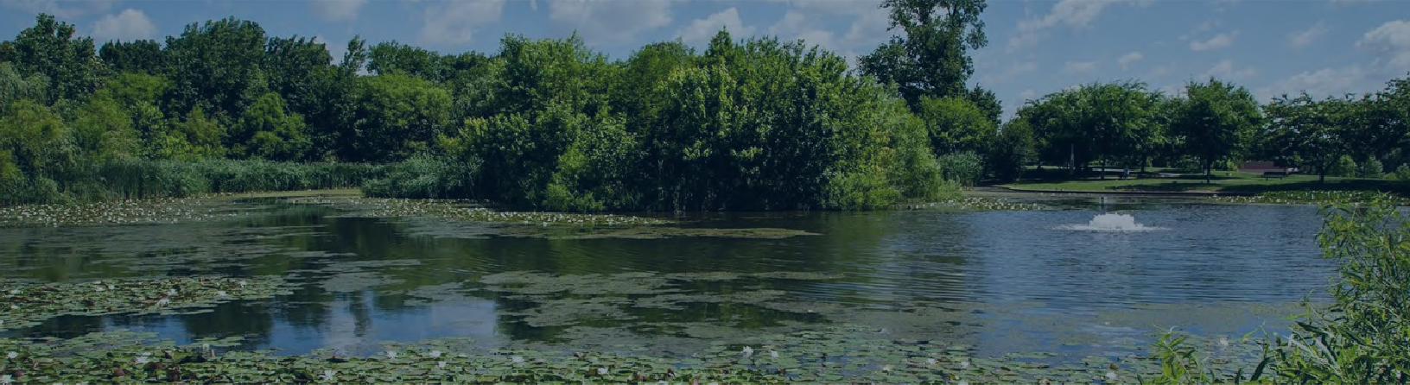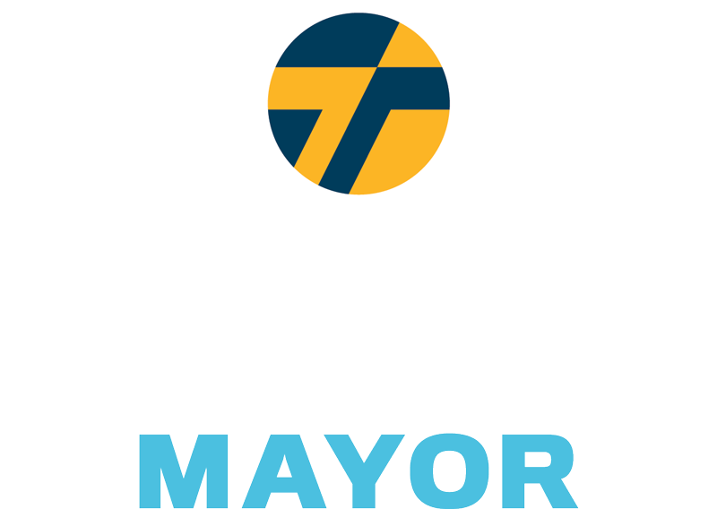

Baltimore is in desperate need of a government that runs efficiently and provides reliable, quality services. Across our city, you will encounter overflowing trash cans, dumped debris, and litter in our streets and waterways.

We need common sense solutions to clean up our city.

2X Twice weekly trash pick up at community request Double the number of trash cans on the streets

A+ Establish Clean Streets Index, grading cleanliness of every city street Make dumpsters available for community weekend clean ups

Use enhanced technology to crack down on illegal dumping

Ensure Citizen Drop-Off Centers are open seven days a week

Develop Materials Recovery Facility and a circular economy around City waste